Introduction to

Japanese Culture and Civilization
OFFERED SUMMER SEMESTER _ 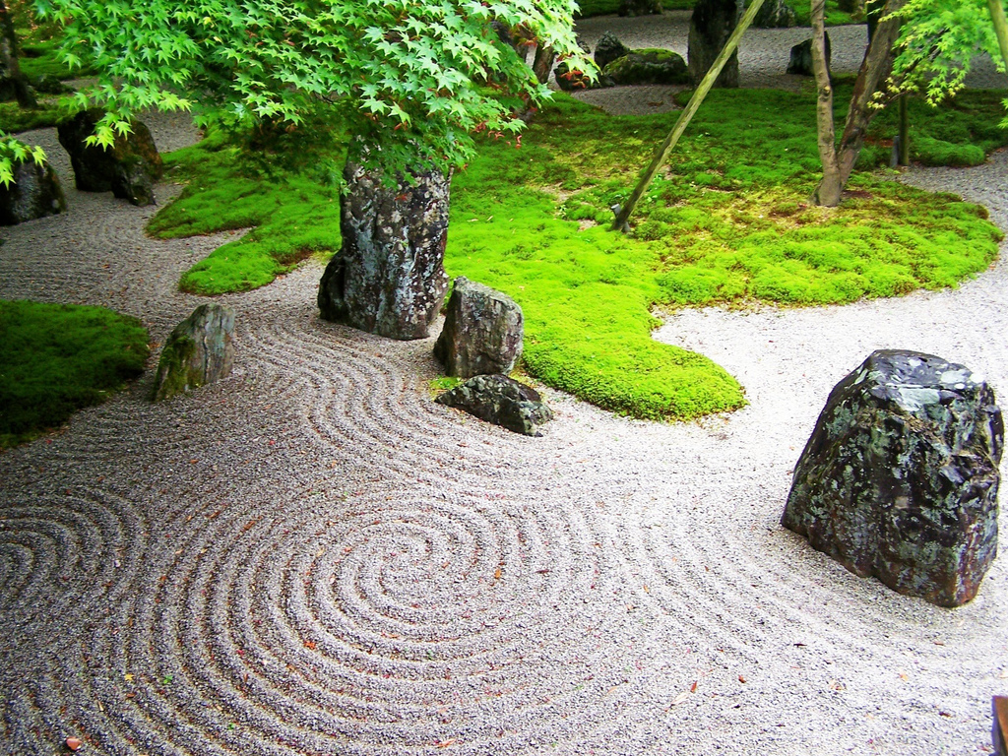
_{Stay at home edition}

satisfy General Education or Japanese requirements
increase your familiarity with historical periods
learn basic geography of East Asia
explore the roots of Japanese popular culture
learn about political, aesthetic, and literary traditions
impress your friends over sushi
prepare for the 2020 2021Tokyo Olympics
_{Offered Summer Session 1} May 11-June 20 CRN 21164

